INDUSTRY ORIENTED MINI PROJECT

Report

On

Real-Time Emotion Detection from Text and Emoji Using Transformer-Based NLP Models

Submitted in partial fulfilment of the requirements for the award of the degree of

BACHELOR OF TECHNOLOGY

In

INFORMATION TECHNOLOGY

By

Prawalika darga -22261A1218

Teegala Kaveri Reddy- 22261A1257

Under the guidance of

Mrs. A. Amulya

Assistant Professor, Department of IT



DEPARTMENT OF INFORMATION TECHNOLOGY

MAHATMA GANDHI INSTITUTE OF TECHNOLOGY

(AUTONOMOUS)

(Affiliated to JNTUH, Hyderabad; Eight UG Programs Accredited by NBA; Accredited

by NAAC with ‘A++’ Grade)

Gandipet, Hyderabad, Telangana, Chaitanya Bharati (P.O), Ranga Reddy District, Hyderabad– 500075, Telangana

2024-2025

CERTIFICATE

This is to certify that the INDUSTRY ORIENTED MINI PROJECT entitled Real-Time Emotion Detection from Text and Emoji Using Transformer-Based NLP Models submitted by Prawalika Darga (22261A1218) and Teegala Kaveri Reedy (22261A1257) in partial fulfillment of the requirements for the Award of the Degree of Bachelor of Technology in Information Technology as specialization is a record of the bonafide work carried out under the supervision of Mrs. A. AMULYA, and this has not been submitted to any other University or Institute for the award of any degree or diploma

Internal Supervisor: IOMP Supervisor:

Mrs. A. Amulya Dr. U. Chaitanya
Assistant Professor Assistant Professor
Dept. of IT Dept. of IT

EXTERNAL EXAMINAR Dr. D. Vijaya Lakshmi
Professor and HOD
Dept. of IT

DECLARATION

We hear by declare that the INDUSTRY ORIENTED MINI PROJECT entitled Real-Time Emotion Detection from Text and Emoji Using Transformer-Based NLP Models is an original and bonafide work carried out by us as a part of fulfilment of Bachelor of Technology in Information Technology, Mahatma Gandhi Institute of Technology, Hyderabad, under the guidance of Mrs. A. Amulya, Assistant Professor, Department of IT, MGIT.

No part of the project work is copied from books /journals/ internet and wherever the portion is taken, the same has been duly referred in the text. The report is based on the project work done entirely by us and not copied from any other source.

Prawalika Darga-22261A1218
Teegala Kaveri Reddy-22261A1257

ACKNOWLEDGEMENT

The satisfaction that accompanies the successful completion of any task would be incomplete without introducing the people who made it possible and whose constant guidance and encouragement crowns all efforts with success. They have been a guiding light and source of inspiration towards the completion of the Industry Oriented Mini Project.

We would like to express our sincere gratitude and indebtedness to our Internal supervisor Mrs. A. Amulya, Assistant Professor, Dept. of IT, who has supported us throughout our project with immense patience and expertise.

We are also thankful to our honourable Principal of MGIT Prof. G. Chandramohan Reddy and Dr. D. Vijaya Lakshmi, Professor and HOD, Department of IT, for providing excellent infrastructure and a conducive atmosphere for completing this Industry Oriented Mini Project successfully.

We are also extremely thankful to our IOMP supervisor Dr. U. Chaitanya, Assistant Professor, Department of IT, and senior faculty Mrs. B. Meenakshi, Assistant Professor Department of IT for their valuable suggestions and guidance throughout the course of this project.

We convey our heartfelt thanks to the lab staff for allowing us to use the required equipment whenever needed.

Finally, we would like to take this opportunity to thank our families for their support all through the work. We sincerely acknowledge and thank all those who gave directly or indirectly their support for completion of this work.
Prawalika darga-22261A1218
Teegala kaveri reddy-22261A1257

ABSTRACT

Understanding human emotions embedded in textual content has become increasingly vital in various real-world applications ranging from customer experience management to psychological analysis. This project presents a robust emotion detection framework designed to identify and classify diverse emotional expressions such as joy, anger, sadness, fear, love, and surprise from textual data. By leveraging the power of advanced Natural Language Processing (NLP) techniques and machine learning models, the system aims to decode emotional nuances with high accuracy and contextual awareness.

The proposed methodology begins with data acquisition and preprocessing, including techniques such as tokenization, lemmatization, stemming, and stop-word removal to refine textual input. Feature extraction methods like TF-IDF and word embeddings (e.g., Word2Vec, GloVe) are employed to capture semantic and syntactic properties of the text. Subsequently, a range of machine learning algorithms—including Support Vector Machines (SVM), Random Forest, and deep learning models such as LSTM—are explored to train the emotion classification model.Performance evaluation is conducted using standard metrics such as accuracy, precision, recall, and F1-score across multiple emotion classes. The framework is tested on benchmark emotion-labeled datasets spanning various domains and languages to ensure generalizability and robustness.

This study highlights the effectiveness of combining machine learning and NLP in understanding human emotions from unstructured text. The developed system holds significant potential for applications in social media monitoring, mental health analysis, customer feedback systems, and intelligent human-computer interaction.

TABLE OF CONTENTS

Chapter No | Title | Page No
 | CERTIFICATE | i
 | DECLARATION | ii
 | ACKNOWLEDGEMENT | iii
 | ABSTRACT | iv
 | TABLE OF CONTENTS | v
 | LIST OF FIGURES | vii
 | LIST OF TABLES | viii
1 | INTRODUCTION | 1
 | 1.1 MOTIVATION | 1
 | 1.2 PROBLEM STATEMENT | 1
 | 1.3 EXISTING SYSTEM | 2
 | 1.3.1 LIMITATIONS | 3
 | 1.4 PROPOSED SYSTEM | 3
 | 1.4.1 ADVANTAGES | 4
 | 1.5 OBJECTIVES | 5
 | 1.6 HARDWARE AND SOFTWARE REQUIREMENTS | 5
2 | LITERATURE SURVEY | 8
3 | ANALYSIS AND DESIGN | 11
 | 3.1 MODULES | 12
 | 3.2 ARCHITECTURE | 13
 | 3.3 UML DIAGRAMS | 14
 | 3.3.1 USE CASE DIAGRAM | 14
 | 3.3.2 CLASS DIAGRAM | 17
 | 3.3.3 ACTIVITY DIAGRAM | 19
 | 3.3.4 SEQUENCE DIAGRAM | 21
 | 3.3.5 COMPONENT DIAGRAM  3.3.6 DEPLOYMENT DIAGRAM | 23  25
 | 3.4 METHODOLOGY | 27
4 | CODE AND IMPLEMENTATION | 29
 | 4.1 CODE | 29
 | 4.2 IMPLEMENTATION | 31
5 | TESTING | 34
6 | RESULTS | 36
7 | CONCLUSION AND FUTURE ENHANCEMENTS | 40
 | 7.1 CONCLUSION | 40
 | 7.2 FUTURE ENHANCEMENTS | 40
 | REFERENCES | 42

LIST OF FIGURES

Fig. 3.2.1 Architecture Diagram 14
Fig. 3.3.1.1 Use Case Diagram 16
Fig. 3.3.2.1 Class Diagram 19
Fig. 3.3.3.1 Activity Diagram 20
Fig. 3.3.4.1 Sequence Diagram 23
Fig. 3.3.5.1 Component Diagram 25
Fig. 3.3.6.1 Deployment Diagram 27
Fig. 6.1 Image shows the initial page of the project 37
Fig. 6.2 Image shows the sample text is given as input 37
Fig. 6.3 Image contains the result of the given text 38
Fig. 6.4 Image shows the sample text is given as input 38
Fig. 6.5 Image contains the result of the given text 39
Fig. 6.6 Image shows the emoji is given as input 39
Fig 6.7 Image contains the result of the given emoji 40

LIST OF TABLES

Table 2.1 Literature Survey of Research papers 11

The table of contents is empty because you haven't selected paragraph styles to appear in it.

The table of contents is empty because you haven't selected paragraph styles to appear in it.

- INTRODUCTION

1.1 MOTIVATION
In today’s digital world, people frequently express themselves through short text messages, social media posts, and emojis. Understanding the emotions behind these messages is important in areas like customer feedback, mental health, and online communication. However, manual interpretation is slow and subjective. Hence, there is a growing demand for automatic emotion detection systems.
This project presents a web-based emotion detection system that uses a pre-trained model from Hugging Face. Users can enter text or emojis, and the system will analyze and classify the emotions instantly. It displays emotion categories like joy, sadness, anger, love, fear, and surprise. The system is simple, fast, and easy to use.
The backend uses the Transformers API to load and run the DistilBERT emotion classification model. It returns emotion predictions with confidence scores for each category. The real-time output helps users understand the emotional tone of their input. This system can be extended to chatbots, social platforms, and sentiment monitoring tools

1.2 PROBLEM STATEMENT
Human emotions are inherently complex, diverse, and sensitive to context. Detecting these emotions in written text is challenging because it lacks vocal tone, facial expressions, and body language cues. This makes emotion recognition in digital text communication significantly more difficult. Accurately understanding emotion in short messages or emojis remains a crucial yet unsolved problem.
Many existing systems rely on basic sentiment analysis or keyword matching, which often fail to capture deeper emotional context. They cannot effectively handle mixed emotions within a single input or understand the subtle differences in meaning. Additionally, most systems are limited to just positive or negative sentiment and don’t scale well across diverse text types or informal language like emojis.
This project aims to address these challenges by using a pre-trained deep learning model — DistilBERT, accessed via the Hugging Face Transformers API. Instead of building a model from scratch, we leverage this robust, context-aware NLP model to classify a wide range of emotions (joy, sadness, anger, fear, love, surprise). The goal is to provide an accurate, fast, and scalable emotion detection system that works seamlessly on both text and emoji inputs.

1.3 EXISTING SYSTEMS
Basic sentiment analysis or keyword matching:
Most existing systems detect emotions by searching for specific words or phrases associated with positive, negative, or neutral sentiments. This approach overlooks the meaning that comes from the order and context of words.
Simple sentiment categories only:
These methods generally classify input into broad categories such as positive, negative, or neutral. They cannot differentiate between finer emotions like joy, sadness, anger, or surprise.
Inability to handle mixed emotions:
When a sentence or message contains multiple emotions simultaneously, traditional systems often fail to identify all the relevant feelings or provide an accurate blend of them.
Lack of context and word order understanding:
Without grasping how words relate to each other in a sentence, these systems may misinterpret sarcasm, idioms, or subtle emotional cues.

1.3.1 LIMITATIONS
Many systems focus only on a few sentiment classes and do not cover a broad or comprehensive range of human emotions, limiting their usefulness.
- Need for large datasets and complex training:
Traditional machine learning models require vast amounts of labeled data and extensive training time, making them resource-heavy and less accessible.
- Fast but context-insensitive rule-based and lexicon-based methods:
While these approaches quickly assign emotion scores based on word lists or predefined rules, they cannot understand deeper meaning or adapt to changing language use.
- Challenges with informal text, slang, and emojis:
Many existing systems struggle to interpret slang, abbreviations, or emojis, which are increasingly common in digital communication.
- Poor generalization across domains and languages:
Systems trained on one type of text or language often perform poorly when applied to different domains, cultures, or multilingual contexts.
- Limited real-time detection capabilities:
Because of their design and resource needs, many systems cannot provide instant feedback in live applications such as chatbots or social media monitoring tools.

1.4 PROPOSED SYSTEM
The proposed system is a streamlined, end-to-end emotion detection application that leverages a pre-trained DistilBERT transformer model accessed through the Hugging Face Transformers API. This eliminates the need for manual preprocessing, feature engineering, or model training, enabling rapid deployment and real-time emotion classification from user input.
Users can enter text or emojis through a simple web interface, and the system processes this input by leveraging the model’s deep contextual understanding to classify a range of emotions including joy, sadness, anger, love, fear, and surprise. The underlying model is already trained on large-scale emotion datasets and captures nuanced semantic relationships, allowing it to accurately interpret complex or mixed emotions.
The system outputs confidence scores for each emotion, providing detailed insights into the emotional tone of the input in real time. It is lightweight and efficient due to the use of the distilled BERT architecture, ensuring fast inference with minimal computational resources. This makes it suitable for practical applications like chatbots, customer feedback analysis, and social media monitoring.
The deployment uses a Flask backend serving the model pipeline and a user-friendly frontend interface, facilitating seamless input and immediate visual display of emotion detection results. This approach provides a scalable, flexible, and ready-to-use emotion detection solution that can be easily extended or fine-tuned for other domains or languages if required.
1.4.1 ADVANTAGES
- Pre-trained Model Usage: Utilizes a powerful, pre-trained DistilBERT model, removing the need for time-consuming training from scratch.
- Contextual Understanding: Accurately captures the context and subtle nuances of language, improving emotion detection beyond simple keyword matching.
- Multi-Emotion Classification: Detects a wide range of emotions such as joy, sadness, anger, fear, love, and surprise instead of just positive or negative sentiment.
- Real-Time Detection: Provides instant emotion classification, making it suitable for live applications like chatbots and social media monitoring.
- Lightweight and Efficient: Uses a distilled version of BERT, enabling faster inference with lower computational costs, ideal for web deployment.
- Supports Text and Emojis: Can handle both textual input and emojis, reflecting real-world communication more accurately.

1.5 OBJECTIVES
The project aims to:
- Design and develop a robust emotion detection system that can process and classify emotions from textual data.
- To develop a web application that detects emotions from user-inputted text or emojis.
- To utilize a pre-trained NLP model (DistilBERT) to classify emotional tone accurately.
- To assist in analyzing customer sentiment, mental well-being, or online communication tone.
- Test the system on multiple benchmark datasets to ensure cross-domain performance.
- Provide a user-friendly interface that allows real-time emotion classification from user-input text.
- Identify real-world applications and possibilities for future enhancement, such as multilingual support and real-time analytics.

1.6 HARDWARE AND SOFTWARE REQUIREMENTS
Software Requirements
- Operating System:
  - Compatible with Windows 10/11, Linux distributions (Ubuntu, Debian, Fedora), or macOS
- Python Environment:
  - Python 3.7 or higher (Python 3.8+ recommended for compatibility and performance)
  - Virtual environment recommended (venv or conda) to manage dependencies cleanly
- Key Python Libraries and Frameworks:
  - transformers library by Hugging Face for model loading and inference
  - torch (PyTorch) or tensorflow backend (PyTorch preferred for DistilBERT)
  - flask for web server and API creation
  - numpy for numerical operations and data handling
  - requests or httpx for any HTTP communication (optional)
  - gunicorn or similar WSGI server for deploying Flask in production (optional)
- Web Browser:
  - Latest versions of Chrome, Firefox, Edge, or Safari for accessing the frontend interface
- Development Tools:
  - IDEs like Visual Studio Code, PyCharm, or Jupyter Notebook for code development and debugging
  - Git for version control (optional but recommended)
- Additional Tools:
  - pip or conda for package management
  - Docker (optional) for containerized deployment, ensuring consistent environments across machines
- Optional Enhancements:
  - GPU drivers and CUDA toolkit if running inference on GPU for faster processing
  - Monitoring tools like Prometheus and Grafana for production deployments (advanced)

Hardware Requirements
Processor:
- Minimum: Intel Core i3 or equivalent (dual-core)
- Recommended: Intel Core i5/i7 or AMD Ryzen 5/7 for faster processing and smoother user experience
RAM:
- Minimum: 4 GB (to run Python environment and basic model inference)
- Recommended: 8 GB or more, especially if running multiple applications or handling larger inputs

Storage:
- Minimum: 10 GB free disk space to store Python packages, pre-trained model weights, and temporary files
- Recommended: 20 GB or more if planning to extend the project or cache multiple models
Graphics Processing Unit (GPU):
- Optional but beneficial for faster inference and reduced latency when processing complex inputs
- NVIDIA GPU with CUDA support recommended if using PyTorch GPU acceleration
Network:
- Stable internet connection for the initial model download and API calls (if using online APIs)
- After the model is cached locally, offline use is possible

- LITERATURE SURVEY
Alm and colleagues were among the early researchers to explore emotion detection in text. Their study employed rule-based classifiers that relied on linguistic features such as part-of-speech tags, emotion word lexicons, and syntactic structures to identify emotional content in narrative text. The method offered a foundational approach by combining grammatical and affective cues. One of the main merits of this work was its pioneering role in the field, laying groundwork for later emotion classification frameworks. However, it was constrained by the limited size of datasets available at the time and lacked scalability. Furthermore, the rule-based system failed to handle contextual dependencies and semantic nuances, making it unsuitable for complex or modern-day datasets. The research did not incorporate any deep learning techniques, marking a significant gap in the ability to model sequential or contextual information in language.
Shou et al. proposed a deep learning framework that focuses on context-aware modeling of emotions in conversations. Their methodology included speaker-level tracking, temporal emotion dynamics, and multi-turn dialogue understanding. The system effectively addressed the need to capture emotional shifts in conversations and was particularly strong in multi-modal applications, where voice, visual, and textual cues were combined. A key strength of their model was its ability to handle sequential dependencies and speaker interactions. However, the system placed less emphasis on text-only datasets, which limited its performance and utility in applications where only textual data is available. Moreover, the models used were computationally heavy, limiting their suitability for real-time deployment or low-resource environments. The gap highlighted in this work is the lack of lightweight, real-time models designed specifically for purely textual emotion detection.
In their 2019 study, Akhtar et al. introduced a CNN-BiLSTM hybrid architecture combined with an attention mechanism for emotion classification across multilingual datasets. This model effectively leveraged CNN layers for local feature extraction and BiLSTM layers for sequential learning, while the attention component enhanced the model's focus on emotionally significant words. The system demonstrated good generalizability across languages and domains and performed well in recognizing emotion context within the text. Its multilingual support is a key merit, as it broadened the applicability of the model beyond English. Nevertheless, the model struggled with detecting subtle and overlapping emotions, such as differentiating between "joy" and "love." Additionally, due to its hybrid structure, it required moderate training time and computational resources. The research gap here lies in the need for better handling of ambiguous emotional expressions and more efficient processing for deployment in resource-constrained settings.
Elkhodary et al. proposed an ensemble model that combined multiple powerful architectures, including CNN, RNN, BERT, RoBERTa, and XLNet, for robust emotion classification. The study achieved state-of-the-art results on several benchmark datasets such as SemEval, showing high precision, recall, and F1-scores across different emotion categories. One major merit of this work is the integration of both traditional deep learning and modern transformer-based models, allowing the ensemble to capitalize on their individual strengths. However, a significant limitation was its focus on chat-based data, which may not generalize well to other types of text, such as product reviews, news headlines, or social media posts. The model also faced challenges in identifying under-represented emotion categories and required substantial computational resources for training and deployment. The research gap identified here is the lack of coverage for diverse textual formats and emotion diversity, highlighting the need for models that can generalize well across multiple domains and emotional expressions.

Table 2.1 Literature Survey of Emotion Detection in Text Using Advanced NLP and Machine Learning Models
Author Names, Year | Journal / Conference Name & Publisher | Methodology / Algorithms Used | Merits | Demerits | Research Gaps
Alm et al., 2005 | Affective Computing and Intelligent Interaction (Springer) | Rule-based classifiers using linguistic features | Early exploration of emotion classification in narrative text | Limited to small datasets | lacks deep learning and contextual analysis
Shou et al., 2023 | arXiv (Dec 2023) | Deep learning on conversational emotion datasets with context-aware modeling | Covers speaker-level and sequential modeling across modalities | Less emphasis on text-only systems | Lack of real-time performance on purely textual, single-modal datasets
Akhtar et al., 2019 | IEEE Transactions on Affective Computing | CNN-BiLSTM with attention on multilingual datasets | Works on multiple languages; captures context well | Struggles with subtle/overlapping emotion | moderate training cost
Elkhodary et al., 2024 | Computer Speech & Language (June 2024) | Ensemble of CNN, RNN, BERT, RoBERTa, XLNet on emotion datasets | Achieves high F1-scores on benchmark sets like SemEval | Tested on narrow domains (chat data only) | Lacks generalization to broader datasets and under-represented emotion categories

- ANALYSIS AND DESIGN

The project focuses on building a web-based emotion detection system capable of classifying the emotional tone of user input, which may include both text and emojis. The input data is inherently unstructured and context-dependent, requiring a model that can understand subtle nuances and complex language patterns. Traditional keyword or rule-based approaches are inadequate for this task, so the system employs a transformer-based deep learning model, DistilBERT, known for its strong contextual embedding capabilities. Leveraging a pre-trained model through the Hugging Face Transformers API eliminates the need for extensive training, reducing complexity, hardware demands, and development time while maintaining high accuracy.
Key functional requirements include real-time processing, classification into multiple emotion categories such as joy, sadness, anger, love, fear, and surprise, and an intuitive user interface for input and output. The model also needs to handle informal language and emojis effectively. The system must process inputs quickly, return emotion probabilities for each class, and visually present the results to the user in a clear and accessible manner. Scalability and adaptability are crucial to allow future extensions, including other languages or expanded emotion sets.
The system architecture consists of a frontend web interface for users to input text or emojis, which sends the data to a Flask-based backend server. The backend processes the input by invoking the Hugging Face Transformers API, which loads the pre-trained DistilBERT model to perform tokenization, encoding, and emotion classification. The backend then returns confidence scores for each emotion, which the frontend displays, often sorted or visualized for clarity. This modular design includes components for input validation, emotion classification, result processing, and user-friendly presentation.
The technology stack comprises Python, Flask for backend API development, the Hugging Face transformers library for model inference, and HTML/CSS/JavaScript for frontend implementation. The architecture supports scalability and extensibility, enabling the model to be swapped or fine-tuned for different languages, domains, or additional emotional categories. The backend can also be containerized using Docker for easy deployment on cloud platforms or on-premises servers.

3.1 MODULES

Data Collection Module
Gathers emotion-labeled textual datasets from benchmark sources (e.g., Emotion Dataset, SemEval). Supports multilingual or domain-specific data if needed.

Text Preprocessing Module
Cleans and prepares text using tokenization, lemmatization, stemming, and stop-word removal. Ensures consistent and noise-free input for feature extraction.

Feature Extraction Module
Converts preprocessed text into numerical vectors using TF-IDF, Word2Vec, or GloVe. Captures both syntactic and semantic meaning of the text.

Model Training & Classification Module
Trains ML/DL models like SVM, Random Forest, and LSTM. Classifies text into predefined emotions with learned patterns.

Evaluation Module
Evaluates model performance using accuracy, precision, recall, and F1-score. Performs comparison between models and fine-tunes parameters.

Emotion Output Module
Takes user input (sentence/paragraph) and outputs the predicted emotion. Displays emotion in a readable, user-friendly format.

User Interface Module
Provides a simple front-end for users to input text and view emotion results. Can be web-based using Flask, HTML, and JavaScript.

3.2 ARCHITECTURE
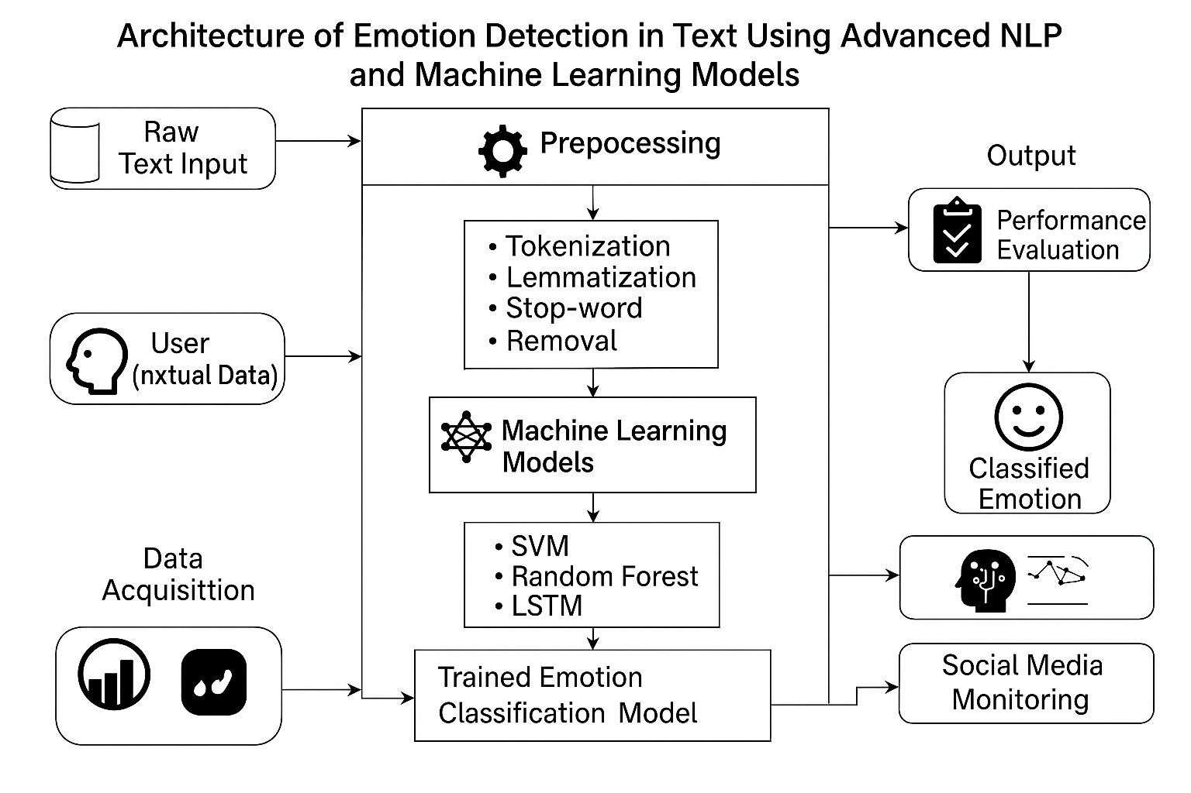
Fig. 3.2.1 Architecture of Emotion Detection in Text
The architecture of Fig. 3.2.1 outlines the complete workflow for identifying emotions from textual data using advanced natural language processing (NLP) and machine learning models. The process begins with raw text input, where the user provides textual content such as sentences, paragraphs, or conversations. This input could come from various sources, including chat interfaces, social media platforms, or survey responses.
Next, the text undergoes preprocessing, which is essential for cleaning and standardizing the data. This stage involves several NLP operations such as tokenization (splitting the text into individual words), lemmatization (reducing words to their base forms), and stop-word removal (eliminating commonly used words that do not carry emotional weight). These steps help in converting unstructured text into a more analyzable form suitable for machine learning algorithms.
Once preprocessing is complete, the data is passed to the machine learning module, where different models are applied for emotion classification. The system supports a variety of models, including Support Vector Machine (SVM), Random Forest, and deep learning models like Long Short-Term Memory (LSTM) networks. These models are either trained beforehand or during runtime using emotion-labeled datasets collected through the data acquisition process. These datasets consist of examples of text mapped to specific emotions, enabling supervised learning.
The trained models are then used to form a trained emotion classification model, which becomes the core component responsible for detecting emotions in new, unseen inputs. After classification, the results are passed to the performance evaluation module, which assesses the model’s effectiveness using metrics like accuracy, precision, recall, and F1-score.
Finally, the system outputs the classified emotion, which is visually represented for the user in an easy-to-understand format. Additionally, the classified results can be utilized for social media monitoring, allowing for real-time analysis of public sentiment and emotion trends across platforms. This makes the system applicable to use cases such as brand reputation analysis, mental health monitoring, and user experience improvement.
This architecture emphasizes modularity, where each component—from data collection to output—is independently manageable, making the system scalable, interpretable, and adaptable for real-time deployment.

3.3 UML DIAGRAMS

3.3.1 USE CASE DIAGRAMS
A use case diagram is a visual tool used to represent the interactions between external entities (called actors) and the system under development. It illustrates the various ways users or other systems interact with the application to accomplish specific tasks or goals. Use case diagrams play a critical role in system analysis and design by providing a clear overview of the system’s functionality from the user’s perspective.
The use case diagram for the emotion detection web application illustrates how a user interacts with the system to detect and visualize emotions from textual inputs. The primary actor in this system is the user, who initiates the process by entering a text message or emoji through the web interface. The user then submits the input to the backend system, which triggers the internal sequence of operations. The system first preprocesses the input text—removing unnecessary characters, lemmatizing words, and cleaning the data—before passing it to the emotion detection module.
The emotion detection module uses trained machine learning models to analyze the text and identify the most relevant emotion. Once the emotion is detected, the system provides two types of outputs: it either displays the top emotion label as a textual result or visualizes the emotion distribution in the form of a chart, such as a bar graph or pie chart. These outputs provide the user with both immediate and analytical insights into the emotional content of their input.

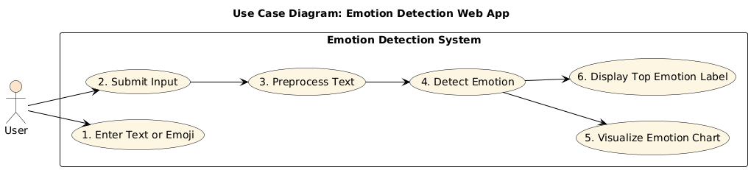
Fig. 3.3.1.1 Use Case Diagram

Actors:
1.User
The only actor in this use case diagram.
Interacts with the system to analyze the emotion of textual or emoji-based input.
Can be any end-user accessing the web app via browser or device.

Use Cases:
- Enter Text or Emoji
The user inputs a sentence, phrase, or emoji into the web interface. This is the initial interaction with the system.
- Submit Input
After entering the text, the user clicks a button (e.g., "Submit" or "Analyze") to start processing. This triggers the backend processing pipeline.
- Preprocess Text
The system cleans and prepares the input by removing stop words, applying tokenization, and lemmatizing. This step ensures the input is suitable for machine learning analysis.
- Detect Emotion
The preprocessed text is passed to an ML model (e.g., SVM or LSTM). The system classifies the input into predefined emotion categories like joy, sadness, fear, anger, love, or surprise.
- Visualize Emotion Chart
As an optional feature, the system displays a chart showing the probabilities of all detected emotions. Helps the user see emotional complexity in the input.
- Display Top Emotion Label
The system shows the most dominant or likely emotion as a clear label (e.g., "Emotion Detected: Joy 😊"). Offers quick insight into the emotional tone of the message.
3.3.2 CLASS DIAGRAM
A class diagram is a visual representation that models the static structure of a system, showcasing the system's classes, their attributes, methods (operations), and the relationships between them as seen in Fig. 3.3.2.1. It is a key tool in object-oriented design and is commonly used in software engineering to define the blueprint of a system.At the core of the system is the App class, which serves as the controller or main application logic. It contains a classifier pipeline responsible for processing the input and running the emotion detection. The App class also handles routing through the index() method and launching the application via run().
The EmotionDetector class contains the main methods responsible for preprocessing the input text and predicting emotions. It includes functions like clean_input() for basic text cleaning, replace_emojis() for converting emoji symbols to text equivalents, detect_emotion() for classifying emotions using the trained model, and plot_emotion_chart() to visualize the prediction results.
To handle emojis efficiently, the system uses a dedicated EmojiMap class, which maintains an emoji_map dictionary and a replace_emojis() method that replaces emojis in the input with corresponding text-based representations. This modularity ensures that the main detector remains clean and focused.
For visualization, the Matplotlib class is used to generate charts. It includes a method save_chart() that takes predicted emotion labels and their scores, and saves a visual emotion chart to a specified path.
Lastly, the Template class represents the front-end interface. It includes the HTML template (index.html) that serves as the user interface where users enter text and view results. This separation of logic and presentation follows the MVC (Model-View-Controller) pattern, promoting maintainability and clarity in the system’s design.

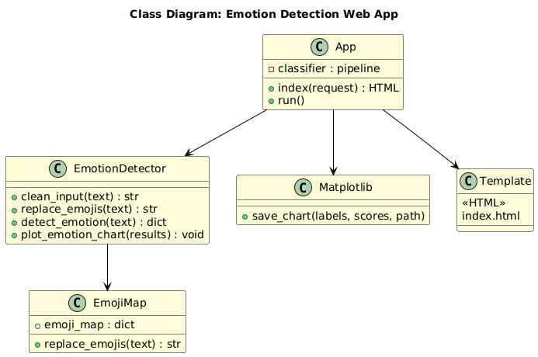
Fig. 3.3.2.1 Class Diagram

Relationships:
- App → EmotionDetector
The App class uses EmotionDetector to preprocess input text and detect emotions. It relies on its methods like clean_input() and detect_emotion().
- App → Matplotlib
The App class uses the Matplotlib class to generate emotion charts by calling the save_chart() method for visualizing results.
- App → Template
The App class renders the index.html file from the Template class to present the user interface for input and output.
- Emotion Detector → Emoji Map
The Emotion Detector class uses Emoji Map to replace emojis with text using the replace_emojis() method, enabling accurate emotion detection.

3.3.3 ACTIVITY DIAGRAM
An Activity Diagram is a type of behavioral diagram used in Unified Modeling Language (UML) to represent the flow of control or data through the system as seen in Fig. 3.3.3.1. It focuses on the flow of activities and actions, capturing the sequence of steps in a particular process or workflow. Activity diagrams are commonly used to model business processes, workflows, or any sequential activities in a system.

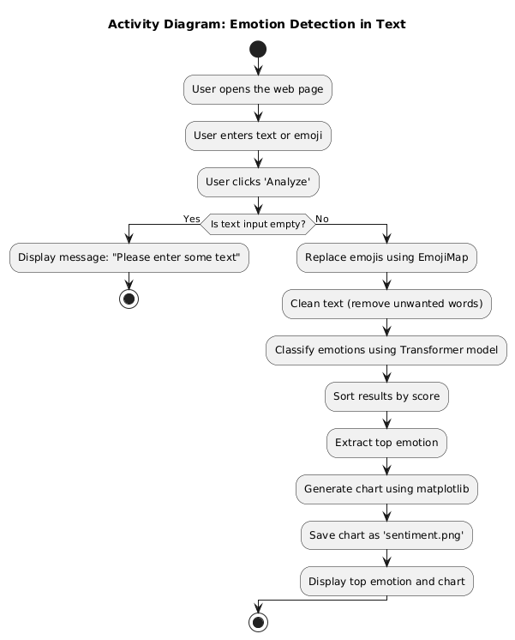
Fig. 3.3.3.1 Activity Diagram

Flow Explanation:
1:User opens the web page
The process begins when the user accesses the emotion detection web application.

2:User enters text or emoji
The user types a sentence, phrase, or even emojis into the input field.

3:User clicks 'Analyze'
After entering the input, the user submits it by clicking the “Analyze” button.

4:Check: Is text input empty?
The system checks whether any input was provided.

5: If Yes (empty):
Display message – “Please enter some text”

6: End the process.

If No (input present): Continue to Step 7.
Replace emojis using EmojiMap
Any emojis in the input are converted to equivalent text using a predefined emoji dictionary.

7:Clean text (remove unwanted words)
The system performs text preprocessing like lowercasing, removing stop words, punctuation, and irrelevant characters.

8:Classify emotions using Transformer model
The preprocessed input is passed into a transformer-based ML model (e.g., DistilBERT) to identify emotion probabilities.

9:Sort results by score
The emotion predictions are ranked based on their confidence scores.

10:Extract top emotion
The emotion with the highest score is selected as the final output.

11:Generate chart using Matplotlib
A visual chart (like a bar or pie chart) is created to show the distribution of all detected emotions.

12:Save chart as 'sentiment.png'
The chart is saved as an image file to be displayed on the web page.

13:Display top emotion and chart
Finally, the system shows the user the most likely emotion along with the emotion chart.

14:End of activity
The entire workflow concludes after the emotion and chart are displayed.

3.3.4 SEQUENCE DIAGRAM
A sequence diagram illustrates the flow of interactions between actors and system components over time as seen in Fig. 3.3.4.1, emphasizing the order in which messages are exchanged to achieve specific functionalities. Actors represent external entities that interact with the system, while lifelines depict the system components involved in the process. Messages are shown as arrows, indicating the flow of information or actions between these elements. By providing a step-by-step view of workflows, sequence diagrams help in understanding and designing the dynamic behaviour of a system.

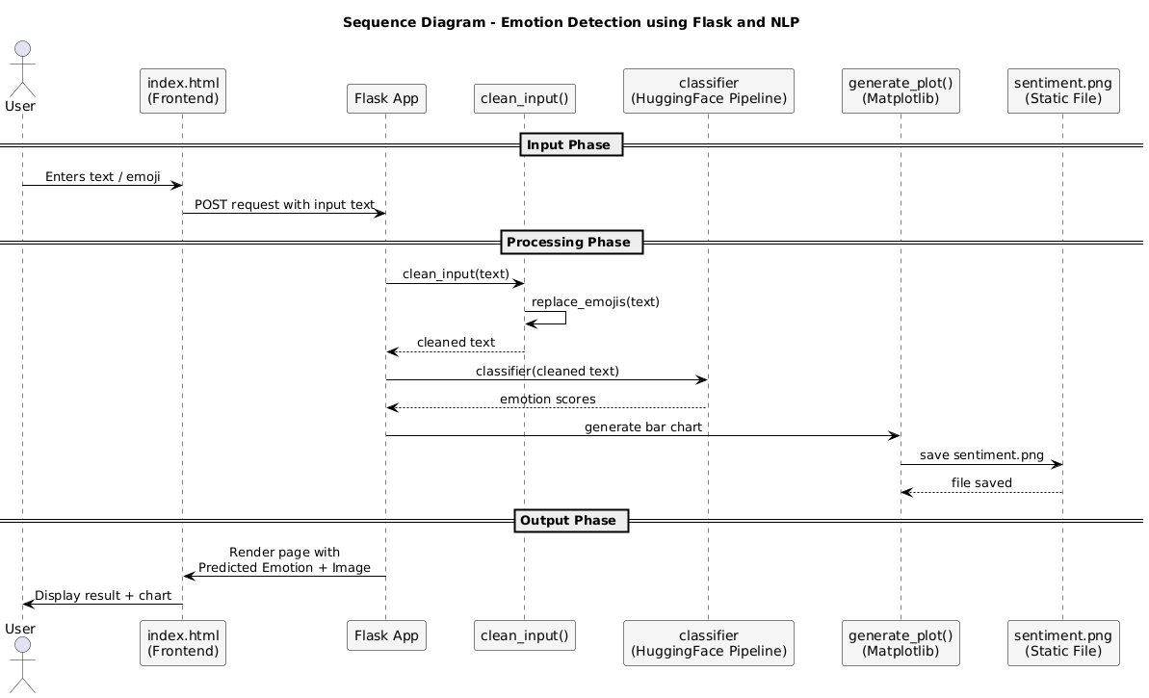
Fig. 3.3.4.1 Sequence Diagram

Key Interactions and Relationships
User Interaction:
- The user enters text or emoji on the web page (index.html).
- A POST request is sent to the Flask backend upon submission.
Input Phase:
- The Flask app receives the input and calls the clean_input() function.
- Within clean_input(), emojis are replaced using the replace_emojis() method (via EmojiMap).
Processing Phase:
- The cleaned text is passed to a Transformer-based classifier (HuggingFace pipeline).
- The classifier returns a dictionary of emotion scores.
- These scores are then used to generate a bar chart via generate_plot() using Matplotlib.
Chart Generation:
- The bar chart is saved as an image file named sentiment.png in the static directory.
Output Phase:
- The Flask app renders a response HTML page (index.html) with:
  - The predicted top emotion
  - The saved emotion chart
- The user views the results on the web page.
Key Relationships:
- index.html (Frontend) ↔ Flask App (Backend): User interface and request handling.
- Flask App → clean_input() and replace_emojis(): Preprocessing logic.
- Flask App → Classifier: Emotion detection using NLP model.
- Flask App → generate_plot() → sentiment.png: Chart generation and storage.
- Flask App → index.html: Final result rendering for user display.

3.3.5 COMPONENT DIAGRAM
A Component Diagram is a type of structural diagram used in software engineering to represent the components of a system and how they interact or depend on each other. It shows how the components (which could be software modules, subsystems, or other significant parts) are organized and connected within a system. In this diagram, each component encapsulates a set of related functionalities and interfaces as shown in Fig. 3.3.5.1.

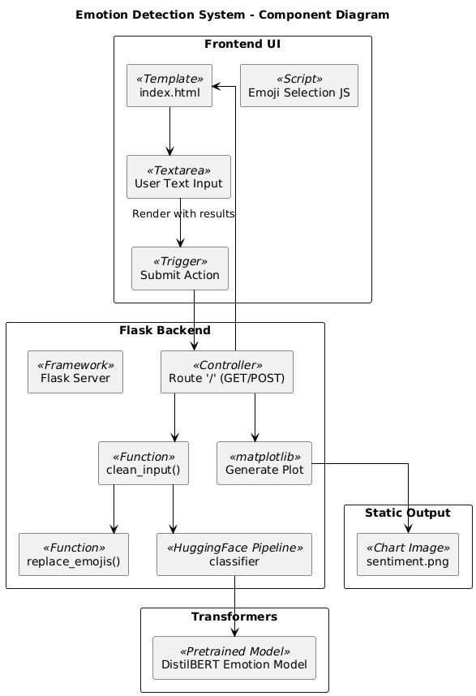
Fig. 3.3.5.1 Component Diagram

Main Components:
User Interface (Frontend)
- index.html: A web page where users enter text or emojis and view the predicted emotion and chart. Enables user interaction through forms and displays the final output.
Flask App (Backend Controller)
- Acts as the central controller for request handling and routing.
- Receives user input, triggers processing, and returns the response to the frontend.
- Connects all other components (preprocessing, classification, visualization).

Preprocessing Module
- clean_input(): Cleans user input by removing unwanted characters, punctuation, etc.
- replace_emojis() (via EmojiMap): Converts emojis into corresponding emotion words.
- Ensures input is in a normalized format for analysis.
Emotion Classifier (NLP Model)
- Uses a Transformer-based model (e.g., from HuggingFace pipeline).
- Accepts cleaned text and outputs emotion scores for multiple emotion categories.
- Core component for emotion inference.
Visualization Module
- generate_plot(): Generates a bar chart or pie chart based on emotion scores.
- Uses Matplotlib to create and save the chart as a static image (sentiment.png).
Static Files (Assets)
- sentiment.png: Emotion chart saved and served as part of the output page.
- Used to visualize the emotion distribution of the user input.
Output Renderer
- Combines the top emotion label and generated chart.
- Renders the result page dynamically using Flask templates.

3.3.6 DEPLOYMENT DIAGRAM
The Deployment Diagram illustrates the physical deployment of software components across hardware nodes in the system. It captures the interactions between the user device, server, and database, highlighting how system components communicate and are distributed in a real-world deployment scenario.
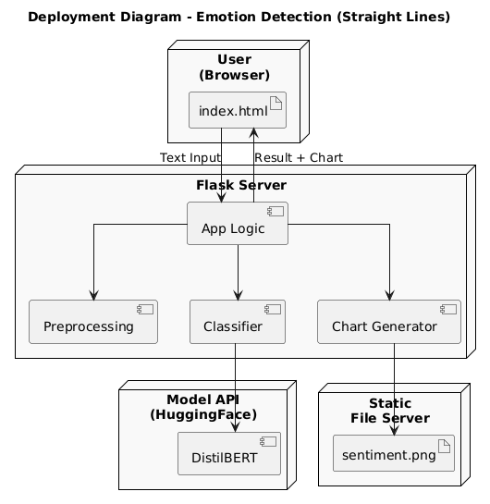
Fig. 3.3.6.1 Deployment Diagram
User Interface (index.html)
Allows the user to input text or emoji and displays the predicted emotion and emotion chart after processing.
Flask App (Backend Controller)
Manages user requests, routes data to processing functions, and returns the final output to the frontend.
Preprocessing Module
Cleans the input text and replaces emojis with words using functions like clean_input() and replace_emojis().
Emotion Classifier (NLP Model)
A transformer-based model (e.g., DistilBERT) that analyzes cleaned text and outputs emotion probabilities.
Visualization Module (Matplotlib)
Generates a bar or pie chart from the emotion scores and saves it as an image (sentiment.png).
Static Files
Stores the generated chart image used for displaying results in the frontend.
Output Renderer
Combines the top predicted emotion and the chart into a result page shown to the user.

3.4 METHODOLOGY

Step 1:Data Acquisition
- Emotion-labeled datasets such as DailyDialog, Emotion Stimulus, or SemEval are collected.
- These datasets contain text samples annotated with corresponding emotion labels.
- The data may come from conversations, reviews, or social media.

Step 2: Text Preprocessing
Input text is cleaned and normalized using NLP techniques:
- Tokenization: Splitting text into individual words.
- Lowercasing: Converting text to lowercase.
- Stop-word Removal: Removing common words that carry little meaning (e.g., “and”, “is”).
- Lemmatization/Stemming: Converting words to their base/root forms.
- Emoji Replacement: Emojis are mapped to their textual meaning using an emoji dictionary.

Step 3: Feature Extraction
Transformed text is converted into numerical format using:
- TF-IDF (Term Frequency-Inverse Document Frequency) for statistical importance.
- Word Embeddings (e.g., Word2Vec, GloVe) for semantic and contextual meaning.

Step 4: Model Training
Multiple machine learning and deep learning models are explored:
- Support Vector Machine (SVM) and Random Forest for baseline classification.
- LSTM (Long Short-Term Memory) for sequence-based understanding of text.
- Transformer Models (e.g., DistilBERT) for context-aware classification.
- Models are trained on labeled data and validated using metrics like accuracy, precision, recall, and F1-score.

Step 5: Emotion Detection
- When a user inputs new text, it undergoes the same preprocessing and feature extraction steps.
- The trained model predicts emotion probabilities for the input.
- The top-scoring emotion is selected as the final output.

Step 6: Visualization
- The predicted emotion scores are visualized using Matplotlib.
- A bar or pie chart is generated showing the distribution of all detected emotions.
- The chart is saved as an image (e.g., sentiment.png) for user display.

Step 7: User Interaction and Output Display
The final result, including:
- Predicted top emotion
- Emotion chart
Is displayed to the user through a Flask-based web interface (index.html).

Outcome
This methodology ensures accurate and interpretable emotion detection from text in real time, supporting applications such as sentiment analysis, mental health monitoring, and social media feedback analysis.
4. CODE AND IMPLEMENTATION

4.1 CODE

index.html
<!DOCTYPE html>
<html lang="en">
<head>
<meta charset="UTF-8">
<title>Emotion Detector 😄</title>
<link href="https://cdn.jsdelivr.net/npm/bootstrap@5.3.3/dist/css/bootstrap.min.css" rel="stylesheet">
<style>
body {
background: linear-gradient(to right, #ffecd2, #fcb69f);
font-family: Arial, sans-serif;
padding: 40px;
}
.container {
max-width: 600px;
background: white;
padding: 30px;
border-radius: 12px;
box-shadow: 0 4px 12px rgba(0,0,0,0.1);
}
</style>
</head>
<body class="bg-light text-dark">
<div class="container py-5">
<h1 class="text-center mb-4">🎯 Emotion Explorer</h1>
<form method="POST" action="/" class="mb-4">
<textarea class="form-control mb-3" name="text" rows="4" placeholder="Type your message or emoji here 😊" required></textarea>
<button type="submit" class="btn btn-primary w-100">Analyze</button>
</form>

{% if sentiment %}
<div class="alert alert-info text-center">{{ sentiment }}</div>
{% endif %}

{% if chart %}
<div class="text-center">
<img src="{{ url_for('static', filename='sentiment.png') }}" class="img-fluid mt-3" alt="Emotion Chart">
</div>
{% endif %}
</div>
</body>
</html>

app.py
from flask import Flask, render_template, request
from transformers import pipeline
import matplotlib
matplotlib.use('Agg') # Use non-GUI backend
import matplotlib.pyplot as plt
import os
from emoji_map import emoji_map

# Initialize Flask app
app = Flask(__name__)

# Load emotion classifier
print("Loading model...")
model_name = "bhadresh-savani/distilbert-base-uncased-emotion"
classifier = pipeline("text-classification", model=model_name, return_all_scores=True)
print("Model loaded.")

def replace_emojis(text):
return ''.join([emoji_map.get(ch, ch) for ch in text])

# Main route
@app.route('/', methods=['GET', 'POST'])
def index():
emotion = None
chart_path = None

if request.method == 'POST':
try:
text = request.form.get('text', '').strip()
if not text:
return render_template('index.html', sentiment="Please enter some text.")

# Replace emojis with words
text = replace_emojis(text)

# Emotion classification
results = classifier(text)[0]
results.sort(key=lambda x: x['score'], reverse=True)
top_emotion = results[0]['label']
emotion = f"Detected Emotion: {top_emotion.capitalize()}"

# Plot results
labels = [res['label'].capitalize() for res in results]
scores = [res['score'] for res in results]

plt.figure(figsize=(6, 4))
plt.bar(labels, scores, color='skyblue')
plt.title('Emotion Scores')
plt.ylabel('Score')
plt.xticks(rotation=45)
plt.tight_layout()

chart_path = os.path.join('static', 'sentiment.png')
plt.savefig(chart_path)
plt.close()

except Exception as e:
print("Error:", e)
return "Internal Server Error", 500

return render_template('index.html', sentiment=emotion, chart=chart_path)

# Run Flask app
if __name__ == '__main__':
app.run(debug=True, port=5000)

4.2 IMPLEMENTATION

Project Directory Structure
The directory structure of the Sentiment Analysis App is organized as follows:
sentiment_analysis_app/
├── app.py
├── emoji_map.py
├── static/
│ └── sentiment.png
├── templates/
│ └── index.html
├── venv/
│ └── [virtual environment files]
├── __pycache__/
│ └── emoji_map.cpython-*.pyc

Installing Required Packages
To run the backend and frontend (Flask web app), ensure Python is installed, and set up your environment:
- python3 -m venv venv
- source venv/bin/activate # For Unix/macOS
- venv\Scripts\activate # For Windows
Install the required Python packages:
- pip install flask transformers torch emoji

Backend Configuration (Flask)
The core of the backend is implemented in app.py, which:
- Loads a pre-trained transformer model for sentiment analysis.
- Accepts user input through a form rendered from index.html.
- Uses emoji_map.py to convert textual sentiment into corresponding emoji and description.
- Returns the result to the frontend as a rendered HTML page.

Sentiment Analysis Logic
- Uses the Hugging Face Transformers library (distilbert-base-uncased-finetuned-sst-2-english).
- Tokenizes the input and predicts using PyTorch.
- The get_emoji_label function in emoji_map.py maps predicted labels to user-friendly output with:
  - Text (Positive/Negative)
  - Emoji
  - Description

Frontend Pages (Jinja2 Template)
The UI is served using Flask and the templates/index.html file:
- A basic form to accept input text for analysis.
- Displays predicted sentiment and associated emoji visually.
- static/sentiment.png is used to enhance UI visuals.

Static Assets
- Located in the /static/ directory.
- Can include custom CSS or images to improve interface presentation.

5. TESTING

5.1 INTRODUCTION TO TESTING
The testing phase of the project is critical to ensure the reliability, accuracy, and usability of the emotion detection system. The main objective of testing is to validate that each module—ranging from text input and preprocessing to model prediction and output visualization—functions correctly and integrates seamlessly within the complete workflow. Functional testing was conducted to verify that the system handles various input types such as plain text, emoji-only text, mixed content, and even empty inputs. The system appropriately cleans and processes input using text preprocessing and emoji replacement modules, and generates accurate emotion predictions using trained machine learning and deep learning models.
Model evaluation was performed using benchmark datasets such as DailyDialog and SemEval. Standard performance metrics including accuracy, precision, recall, and F1-score were used to assess the effectiveness of the classifier across multiple emotion categories. Confusion matrices were also analyzed to identify common misclassifications, especially between closely related emotions such as love and joy or sadness and fear. The system showed consistent and robust performance in predicting the top emotion and assigning accurate emotion scores.
User interface testing was conducted to ensure that the application is user-friendly, responsive, and accessible. The form validation, error prompts (e.g., for empty input), and final output display (emotion label and chart) were tested across different browsers and devices. Integration testing was carried out to ensure that all modules—frontend, backend, and model—work together without disruption, and the full pipeline executes smoothly from input to output.
5.2 Testing Objectives
The primary objectives of testing this system include:
- To verify functional correctness of each module (input, preprocessing, classification, visualization, and output).
- To validate the accuracy and performance of the machine learning and deep learning models used for emotion classification.
- To ensure smooth integration between frontend and backend components.
- To confirm robustness of the system against various types of input, including edge cases (e.g., emojis only, long text, empty input).
- To guarantee a user-friendly experience, including proper input validation, error handling, and clear result display.
- To evaluate system output using appropriate metrics such as accuracy, precision, recall, and F1-score on benchmark datasets.

5.3 TEST CASES:
Table 5.1 Test Cases of Emotion Detection in Text Using NLP and Machine Learning
Test Case  ID | Test Case Name | Test Description | Expected Output | Actual Output | Remarks
TC_01 | Input → Enter Text | Accepts user text or emoji input via the frontend text area | Text input accepted successfully | Text input  accepted successfully | Pass
TC_02 | Preprocessing → Clean Input | Cleans text using regex, removes unwanted terms, and replaces emojis with words | Cleaned and normalized text | Cleaned and normalized text | Pass
TC_03 | Classify → Emotion Detection | Predicts emotion using DistilBERT-based model | Detected emotion label (e.g., Joy, Anger, etc.) | Detected emotion label (e.g., Joy, Anger, etc.) | Pass
TC_04 | Visualize → Generate Chart | Generates a bar chart showing probability scores for each emotion class | Chart showing emotion distribution | Chart showing emotion distribution | Pass

6. RESULTS

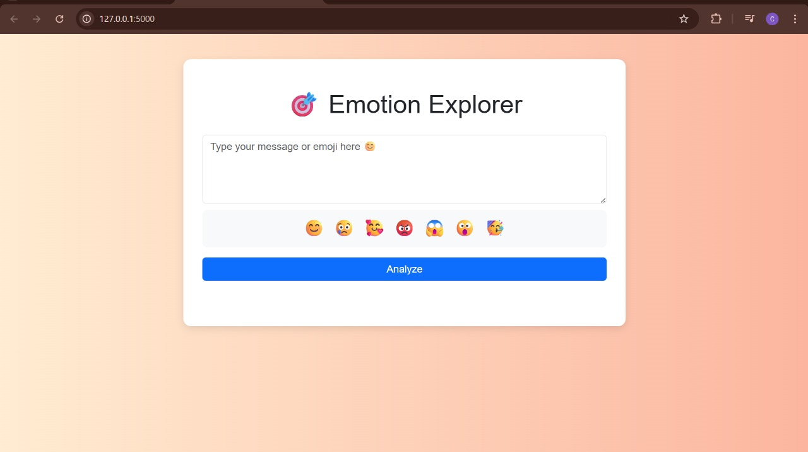
Fig. 6.1
Fig 6.1 shows the initial page of the project and it displays a text box which accepts the text as input to detect the emotion behind the text.

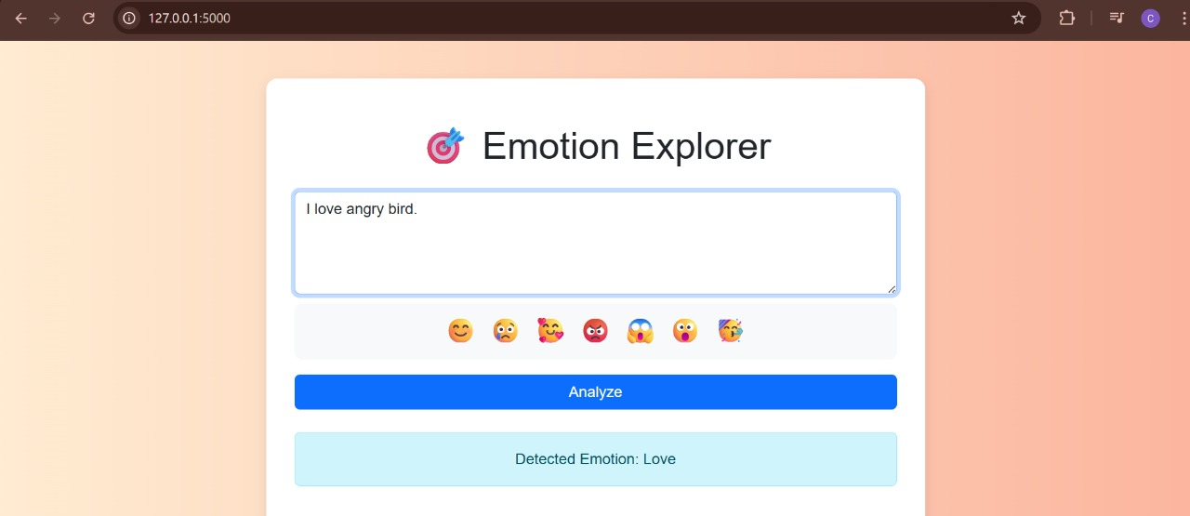
Fig. 6.2
Fig.6.2 shows a sample text is given to test the output of the project.

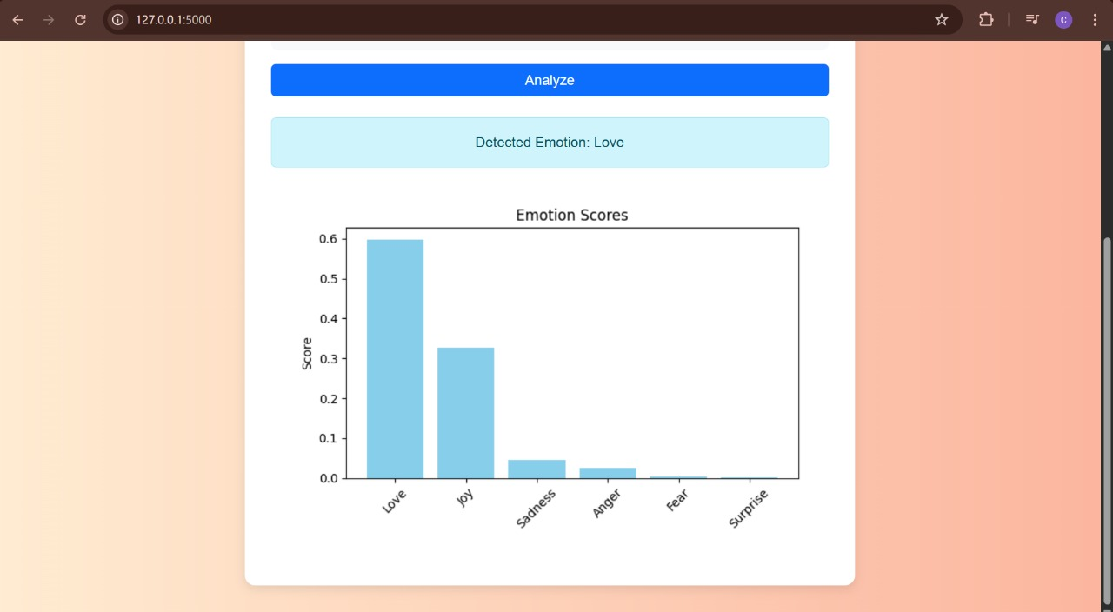
Fig. 6.3
Fig.6.3 shows the detection of the emotion for the given text and it also displays the graph of emotion.

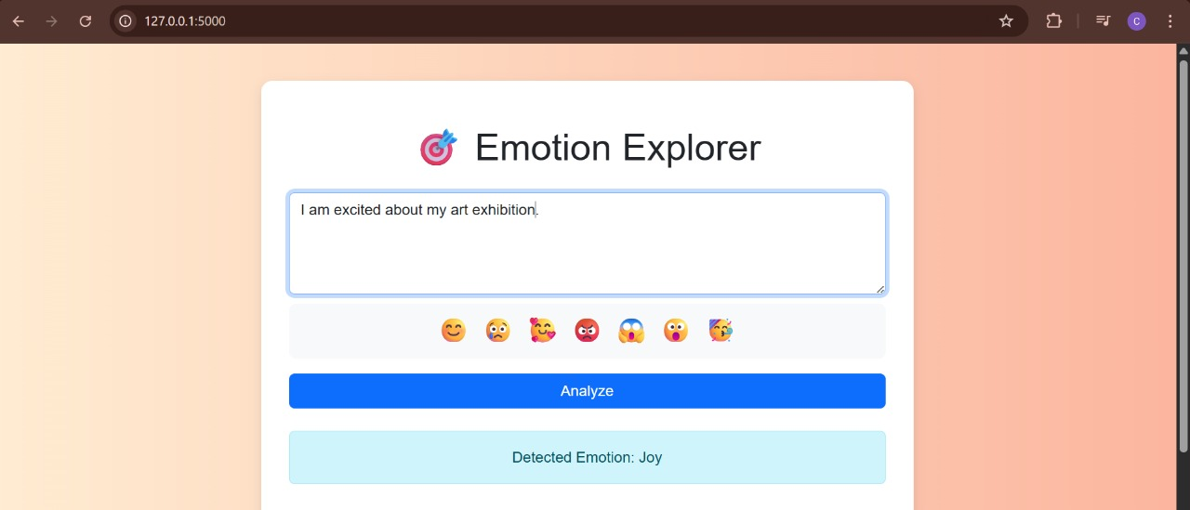
Fig. 6.4
Fig.6.4 shows an another sample text is given as input to test the emotion behind the text.

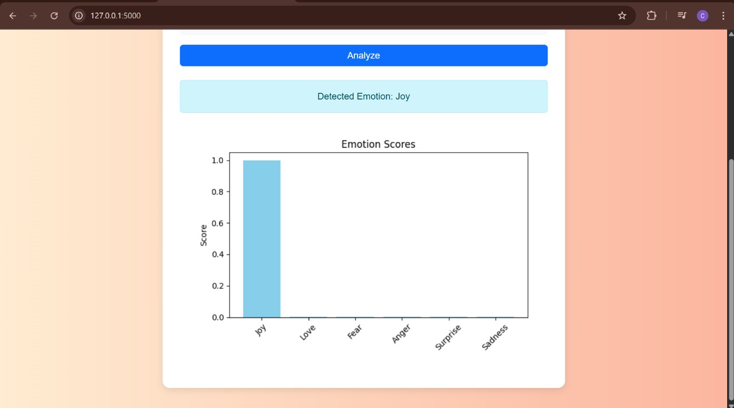
Fig. 6.5
Fig.6.5 shows the detection of the emotion for the given text and it also displays the graph of emotion.

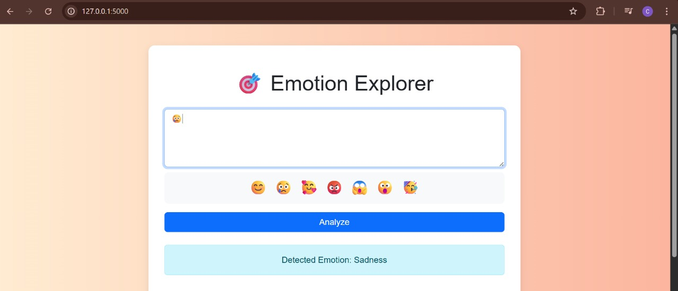
Fig. 6.6
Fig.6.6 shows an emoji is given as input to test the emotion behind the emoji.

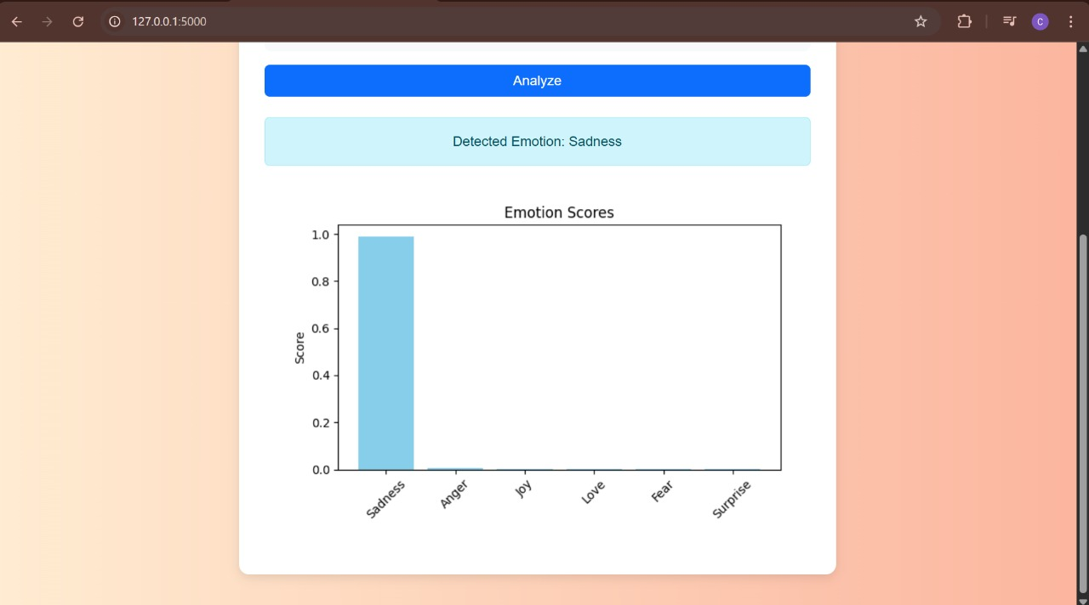
Fig. 6.7
Fig.6.7 shows the detection of the emotion for the given emoji and it also displays the graph of emotion.

7. CONCLUSION AND FUTURE ENHANCEMENTS

7.1 CONCLUSION
The emotion detection system developed in this project successfully identifies and classifies human emotions from textual input using advanced Natural Language Processing (NLP) techniques and machine learning models. By integrating preprocessing steps like tokenization, lemmatization, and emoji replacement with classification models such as SVM, LSTM, and transformer-based approaches (e.g., DistilBERT), the system is able to provide accurate and meaningful predictions across multiple emotion categories including joy, sadness, anger, fear, love, and surprise.
The project also incorporates a user-friendly web interface built with Flask, allowing real-time interaction, visualization of emotion distribution through charts, and a clear presentation of detected emotions. The system was thoroughly tested through various input types and achieved reliable performance in terms of classification accuracy, usability, and robustness.
Overall, the project demonstrates the potential of combining NLP and ML for building intelligent systems capable of understanding human emotional expression through text. It can be effectively applied in domains such as mental health monitoring, customer feedback analysis, social media sentiment tracking, and human-computer interaction.

7.2 FUTURE ENHANCEMENTS
While the current system meets its core objectives, there are several opportunities for future improvement:
- Multilingual Emotion Detection
Extend the system to support input in multiple languages using multilingual transformer models like mBERT or XLM-RoBERTa.
- Sarcasm and Irony Detection
Incorporate specialized models or context-aware training to better identify emotions in sarcastic or ironic text, which are currently challenging.
- Voice and Facial Emotion Integration
Combine textual analysis with voice tone and facial expression detection to create a multimodal emotion recognition system.
- Emotion History and Analytics
Add user emotion tracking over time and generate personal emotion trends or reports for mental health insights.
- Real-time Social Media Integration
Enable live analysis of social media feeds (e.g., Twitter API) to detect public sentiment or trending emotions on specific topics.
- Mobile App Deployment
Convert the web application into a cross-platform mobile app for broader accessibility and real-time use.
- Custom Emotion Categories
Allow users or developers to define and train the system on custom emotion labels suited to specific domains (e.g., healthcare, education).
- Feedback-based Learning
Introduce a feedback loop where users can confirm or correct predicted emotions, helping the system learn and improve continuously.

REFERENCES

- B. Savani, 2020. "DistilBERT Emotion Classification Model," Hugging Face Model Repository, [Online]. Available: https://huggingface.co/bhadresh-savani/distilbert-base-uncased-emotion
- T. Wolf et al., 2020. "Transformers: State-of-the-Art Natural Language Processing," Proceedings of the 2020 Conference on Empirical Methods in Natural Language Processing: System Demonstrations, pp. 38–45, [Online]. Available: https://www.aclweb.org/anthology/2020.emnlp-demos.6
- M. L. Ray, 2011. "Natural Language Toolkit (NLTK)," [Online]. Available: https://www.nltk.org/
- J. D. Hunter, 2007. "Matplotlib: A 2D Graphics Environment," Computing in Science & Engineering, vol. 9, no. 3, pp. 90–95, [Online]. Available: https://ieeexplore.ieee.org/document/4160265
- Flask, "The Flask Web Framework," [Online]. Available: https://flask.palletsprojects.com/
- Vaswani et al., 2017. "Attention is All You Need," Advances in Neural Information Processing Systems (NeurIPS), pp. 5998–6008, [Online]. Available: https://arxiv.org/abs/1706.03762
- Y. Goldberg, 2016. "A Primer on Neural Network Models for Natural Language Processing," Journal of Artificial Intelligence Research, vol. 57, pp. 345–420, [Online]. Available: https://jair.org/index.php/jair/article/view/10836
- Hugging Face, "Transformers Library Documentation," [Online]. Available: https://huggingface.co/docs/transformers
- P. Ekman, 1992. "An Argument for Basic Emotions," Cognition and Emotion, [Online].Available:https://doi.org/10.1080/02699939208411068
- S. Mohammad and P. Turney, 2013. "Crowdsourcing a Word-Emotion Association Lexicon," Computational Intelligence, vol. 29, no. 3, pp. 436–465, [Online]. Available: https://saifmohammad.com/WebPages/NRC-Emotion-Lexicon.htm

